FIBER-OPTIC TEMPERATURE SENSORS
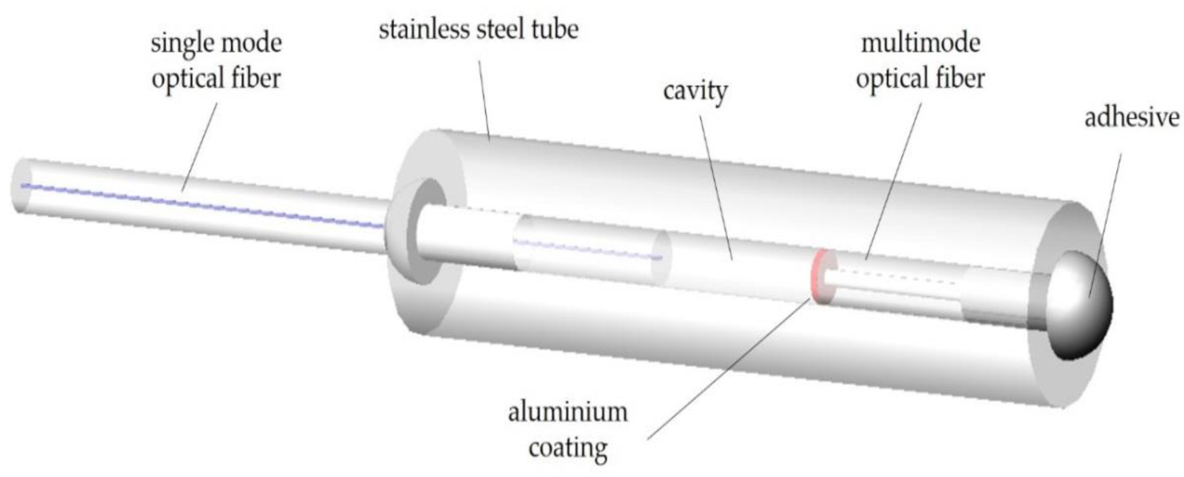
A fiber optic sensor is a sensing device that uses fiber optic technology for measuring physical quantities such as temperature, pressure, strain, voltages and acceleration, to name a few.
In particular, it uses an optical fiber as the sensing element, called an intrinsic sensor, or uses it to transport signals from the remote sensor to the signal processing module (extrinsic sensor).
Fiber optic sensors are immune to electromagnetic interference and can handle extreme conditions, so they are gaining popularity as the sensor of choice for many industries.
Fiber-optic temperature sensors are based on the light absorption/ transmission properties of gallium arsenide (GaAs). The effects of temperature variations on this semiconducting crystal are well known and predictable.
At the measurement end of the fiber-optic temperature sensor is a GaAs crystal. As the crystal’s temperature increases, its transmission spectrum (i.e., the light that is not absorbed) shifts to higher wavelengths. At any given temperature, transmission jumps from essentially 0% to 100% at a specific wavelength. This jump is called the absorption shift. The relationship between the temperature and the specific wavelength at which the absorption shift takes place is very predictable.
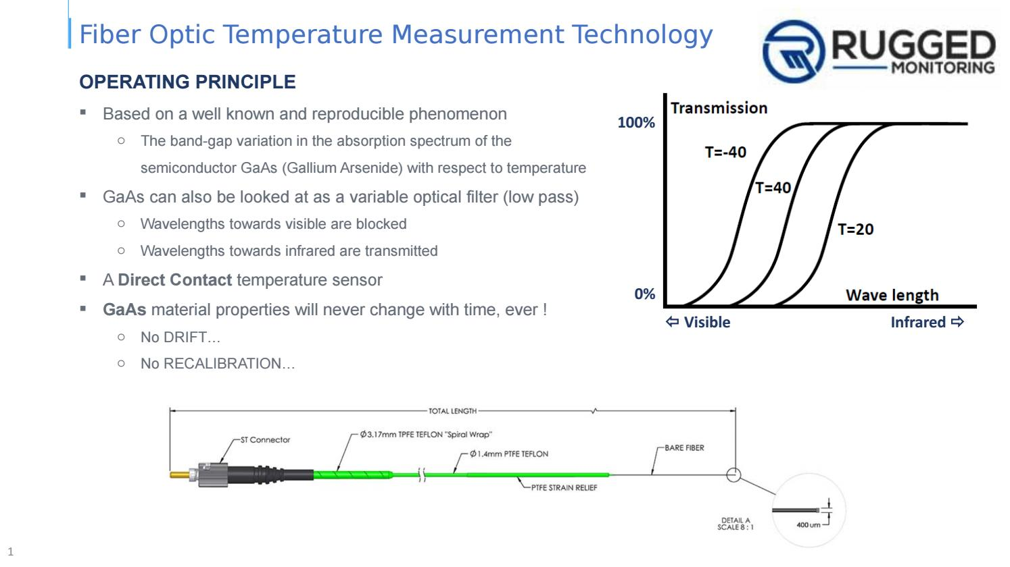
To understand why the absorption shift occurs, it is necessary to look at the variation in the semiconductor’s energy band gap. This band gap refers to the energy required to bump the electrons in the material from a relaxed, steady state into an excited state. As more energy in the form of heat enters the crystal, the band gap becomes narrower—less additional energy is needed to excite an electron.
The photons entering the crystal are what actually excite the electrons. If a photon is carrying enough energy to get an electron across the gap, it will be absorbed. If it is not carrying enough energy, the photon will be transmitted. The shorter a photon’s wavelength, the more energy it carries. Because the band gap narrows as the crystal’s temperature increases, and less energy is needed to jump the gap, photons with less and less energy (longer and longer wavelengths) are absorbed by the band. The effect is to move the absorption shift to longer wavelengths. Consequently, measuring the position of the absorption shift gives a measure of the crystal’s temperature.
Probe Design

A fiber-optic temperature probe must be in contact with the material it is measuring. The more intimate the contact, the faster the crystal will respond to the temperature changes. A tiny crystal of GaAs with a dielectric mirror is bonded to one end of a cleaved optical fiber.
At the opposite end of the probe is a stainless steel ST-type connector, through which white light is injected into the probe.
The light travels down the probe’s optical fiber, where some of it is absorbed by the GaAs crystal. The dielectric mirror reflects unabsorbed light, which returns down the probe to the coupler and is directed to a spectrometer.
The position of the absorption shift is then analyzed and correlated back to temperature. Computation of the absorption shift does not depend on signal intensity; essentially, only the reflected light signature is of interest.
Therefore, the various factors that contribute to attenuation on optical fibers (e.g., fiber length, number and quantity of connections, fiber diameter and composition, bending) do not impose any serious constraints. Furthermore, since the GaAs crystal’s response is universal and constant, no probe calibration is required.
Types of Fiber Optic Temperature sensors
The fiber optic temperature sensors are mainly classified into two types i.e. Interferometric and non-interferometric.
The simple non-interferometric type sensor consists of multi-mode optical fiber and temperature sensitive material. The temperature sensing materials include GaAs, CdTe, Si etc. GaAs is preferred over others due to its better wavelength variation with temperature. These materials exhibit changes in their optical parameters such as absorption, transmission and reflection qualities with variation in the temperature.
The working principle depends on phenomenon of energy band gap shrinkage with increase in the temperature of such semiconductor materials.
In this sensor type, thin semiconductor ship is used as active element. This active element is sandwiched between light source (e.g. LED or laser) and photo detector. In this sensor, constant intensity of light signal is modulated by external temperature when it travels through the optical fiber cable. Moreover its wavelength shifts towards higher side due to gradual increase in the temperature. This is due to optical absorption edge.

Interferometric temperature sensor offers flexible geometry and higher sensitivities hence it can be used for measurement of temperature. It works based on phase modulation by external measurands. Here phase of the beam through sensing fiber is compared with the reference beam. Beam splitter is used in the design of such Mach-Zehnder.
Beam splitter divides the light beam into two parts, one is launched into the sensing part and the other is used as reference.
It consists of a Laser source to emit light. A beam splitter, made of glass plate is inclined at an angle 45⁰ with respect to the direction of the laser beam.
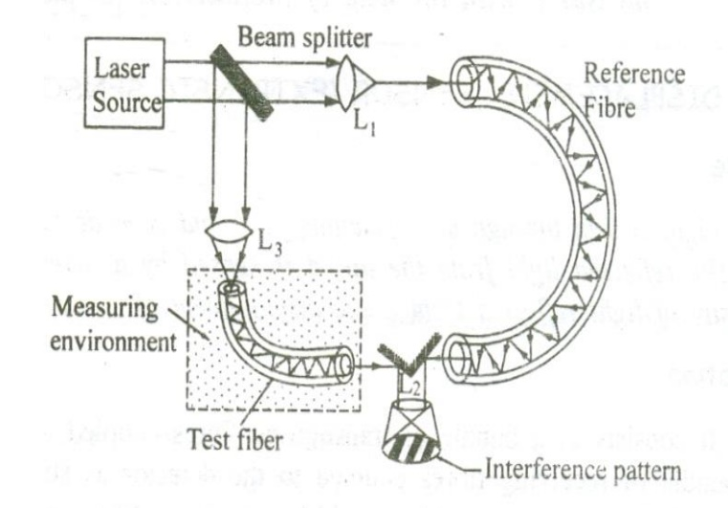

1. A monochromatic source of light is emitted from the laser source.

2. The beam splitter kept at an angle 45⁰ inclination divides the beam emerging from the laser source into two beams (i) main beam and (ii) splitted beam, exactly at right angles to each other.

3. The main beam passes through the lens L1 and is focused onto the reference fiber which is isolated from the environment to be sensed.

4. The beam after passing through the reference fiber then falls on the Lens L2.

5. The splitted beam passes through the Lens L3 and is focused onto the test fiber kept in the environment to be sensed.

6. The splitted beam after passing through the test fiber is made to fall on lens L2.

7. The two beams after passing through the fibers, produces a path difference due to change in parameters such as pressure, temperature etc in the environment.

8. Therefore a path difference is produced between two beams causing the interference pattern as shown in the figure.

9. Thus the change in pressure or temperature can be accurately measured with the help of the interference pattern obtained.

Advantages of Fiber Optic Temperature Sensor
- It is immune from nearby electromagnetic and stray radiation.
- It can be used in environments where high levels of electrical interference exist or where intrinsic safety is a concern.
- It (i.e. non-interferometric type) offers greater accuracy (+/- 1) and faster response time (~2 sec).
- It is light in weight and compact in size.
- It is cheaper due to low manufacturing cost.

- It supports wide temperature range of measurement from -10⁰ C to 300⁰ C. The GaAs offers better wavelength variation with temperature.
Disadvantages of Fiber Optic Temperature Sensor
- The different types of optical temperature sensors will have different temperature range of operation and their accuracy of measurements also vary. These depend on their construction and materials used.
- It is complex to develop measurement systems using fiber optic sensors.
- The users require training before they start using such sensor types.
- Some fiber optic temperature sensors are expensive.

